Experiment- 1

Aim:-Study of Components or Devices of computer network in Detail

Apparatus (Software):- No software or hardware needed.

Procedure: Following should be done to understand this practical.

NIC(Network Interface Card)

- A NIC is the physical component of a computer network that allows communication between computers.
- It is sometimes referred to as a network interface controller or network adapter.
- A NIC is required to connect to and exchange data with other computers, servers, routers, and switches on a network.
- NIC can be wired or wireless, supporting a unique set of networking standards such as Ethernet, Wi-Fi, Bluetooth, and Fiber Channels.
- A wireless NIC uses antennae to connect to a wireless network, whereas a wired NIC uses a network cable and an RJ45 connector.

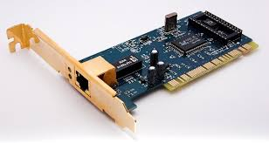

2. HUB
- A hub is an intermediary device that connects multiple end devices on the same network and broadcasts data bits to all of them. It acts as a distribution center.
- A computer makes a request to the hub via cable when it needs data from the network or a particular computer. The request will be sent to the hub, which will relay it to the network.The computers on the network must then determine whether or not the information being broadcast is intended for them.
- It does not perform any filtering or forwarding function and acts as a simple repeater. It is considered an absolute device due to its inefficiency and security issues.
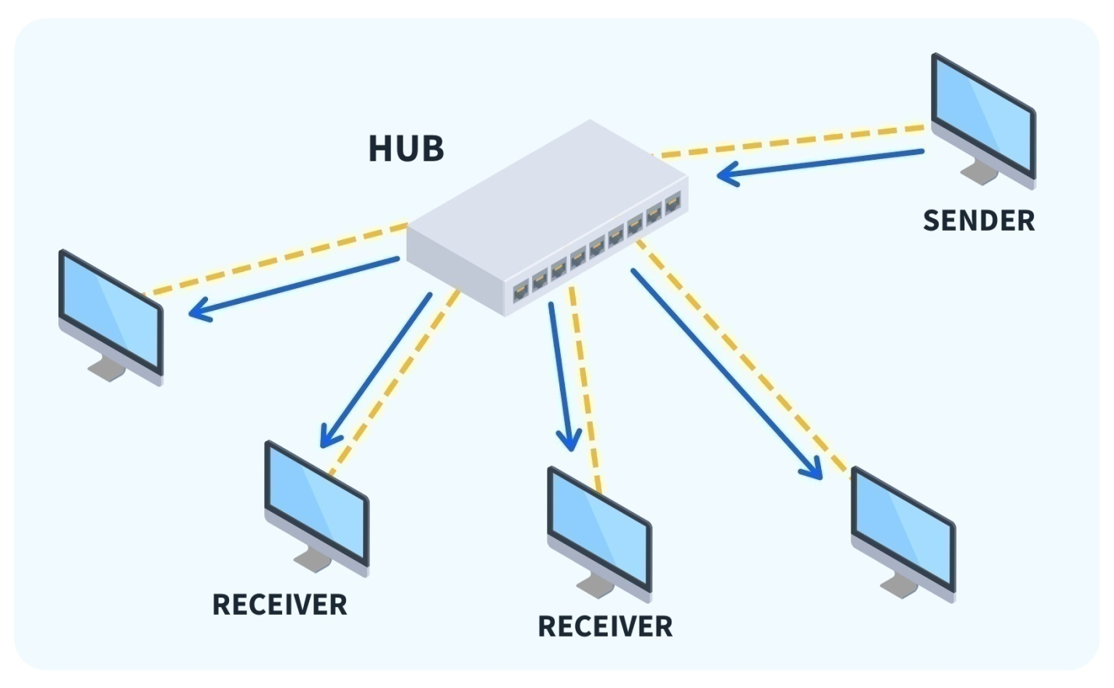

Types of HUB
- Active HUB: Active HUB regenerates and amplifies the electric signal before sending them to all connected device. This hub is suitable to transmit data for long distance connections over the network.
- Passive HUB: As the name suggests it does not amplify or regenerate electric signal, it is the simplest types of Hub among all and it is not suitable for long-distance connections.
- Switching HUB: This is also known as intelligent HUB, they provide some additional functionality over active and passive hubs. They analyze data packets and make decisions based on MAC address and they are operated on DLL(Data Link Layer).

3. Router
- A router is an intermediary device that connects two or more networks and forwards data packets between them.
- It uses routing protocols and algorithms to determine the best path for each packet based on its destination address and other factors.
- It also performs functions such as filtering, security, quality of service (QoS), etc.
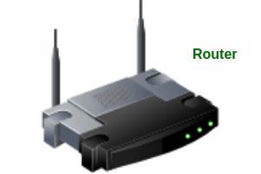

4. Modem

- A Modem is a short form of Modulator/Demodulator.
- It is responsible for the conversion of digital signals originating from a computer or network into analog signals that are capable of being transmitted over a telephone or cable line.
- Upon reaching the terminal point of transmission, the analog signals undergo a conversion process by the modem located at the receiving end, which transforms them into digital signals that the recipient computer or network can understand.
- Cable modems, digital subscriber line modems, and dial-up modems are all examples of the many varieties of available modems.

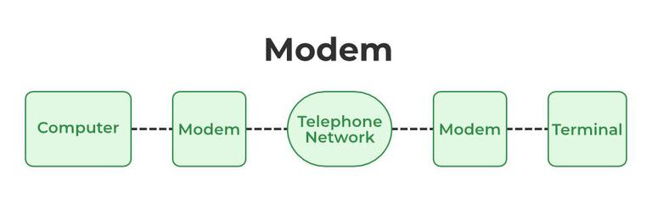

5. Switch
- A switch facilitates data transfer between devices within the same network.
- Switches manage intra-network connections by utilizing MAC addresses to deliver data directly to the intended recipient.
- Modern switches often come with features such as VLAN (Virtual Local Area Network) support, enhancing network segmentation and security.
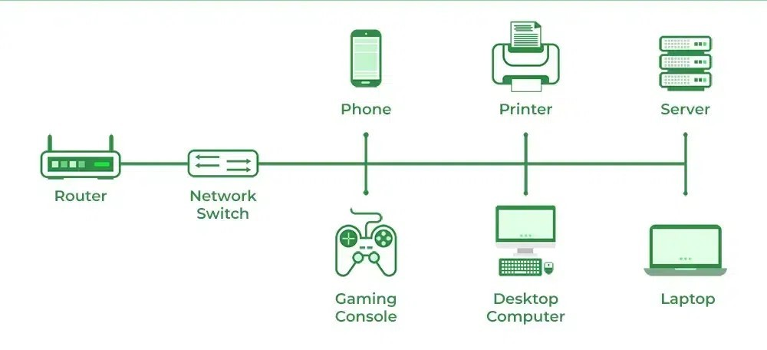
Switches

6. Nodes
Node is a term used to refer to any computing devices such as computers that send and receive network packets across the network.

Types of nodes
- End Nodes: These types of nodes are going to be the starting point or the end point of communication. E.g., computers, security cameras, network printers, etc.
- Intermediary Nodes: These nodes are going to be in between the starting point or end point of the end nodes. E.g., Switches, Bridges, Routers, cell towers, etc.

8. Repeater
- A device that amplifies and regenerates data signals on a network.
- It does not perform any filtering or forwarding function.
- It is used to extend the range of a network or overcome signal attenuation. Because of this, the signal may be sent across greater distances without decreasing its quality. There are a lot of repeaters in a WAN.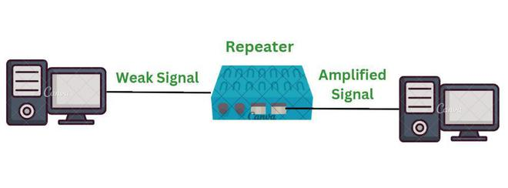

9. Server
- A server is computer programs that provide various functionalities to another computer program.
- The server plays a vital role in facilitating communication, data storage, etc.
- Servers have more data storage as compared to normal computers.
- They are designed for the specific purpose of handling multiple requests from clients.
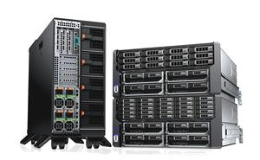
10. Gate Way:
In a communications network, a network node equipped for interfacing with another network that uses different protocols.
- A gateway may contain devices such as protocol translators, impedance matching devices, rate converters, fault isolators, or signal translators as necessary to provide system interoperability. It also requires the establishment of mutually acceptable administrative procedures between both networks.
- A protocol translation/mapping gateway interconnects networks with different network protocol technologies by performing the required protocol conversions.

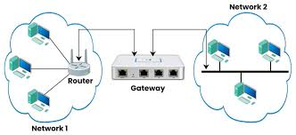

Experiment- 2
Aim: Study of network IP
- Classification of IP address
- Sub netting
- Super netting
Apparatus (Software): NA

Defination:-
A gateway is a connecting point of any network that helps it to connect with different networks. The gateway monitors and controls all the incoming and outgoing traffic of the network.

How does Gateway Work?
Gateway has a simple working methodology of five steps:
Step 1: It gets data from the network
Step 2: It intercepts and analyzes the received data.
Step 3: It routes the data to the destination address.
Step 4: It converts the received data to make that compatible with the receiver network.
Step 5: It sends the final data inside the network.

Procedure: Following is required to be study under this practical.
- Classification of IP address
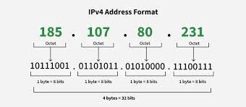

Class | Address Range | Supports
Class A | 1.0.0.1 to 126.255.255.254 | Supports 16 million hosts on each of 127 networks.
Class B | 128.1.0.1 to 191.255.255.254 | Supports 65,000 hosts on each of 16,000 networks.
Class C | 192.0.1.1 to 223.255.254.254 | Supports 254 hosts on each of 2 million networks.
Class D | 224.0.0.0 to 239.255.255.255 | Reserved for multicast groups.
Class E | 240.0.0.0 to 254.255.255.254 | Reserved.

Experiment-3
Aim: Connect the computers in Local Area Network.

Procedure: On the host computer on the host computer.
Follow these steps to share the Internet connection:
1. Log on to the host computer as Administrator or as Owner.
2. Click Start, and then click Control Panel.
3. Click Network and Internet Connections.
4. Click Network Connections.
5. Right-click the connection that you use to connect to the Internet. For example, if you connect to the Internet by using a modem, right-click the connection that you want under Dial-up / other network available.
6. Click Properties.
7. Click the Advanced tab.
8. Under Internet Connection Sharing, select the Allow other network users to connect through this computer's Internet connection check box.
9. If you are sharing a dial-up Internet connection, select the Establish a dial-up connection whenever a computer on my network attempts to access the Internet check box if you want to permit your computer to automatically connect to the Internet.
10. Click OK.

You receive the following message:
When Internet Connection Sharing is enabled; your LAN adapter will be set to use IP address 192.168.0.1. Your computer may lose connectivity with other computers on your network. If these other computers have static IP addresses, it is a good idea to set them to obtain their IP addresses automatically.

Are you sure you want to enable Internet Connection Sharing?

11. Click Yes.
The connection to the Internet is shared to other computers on the local area network (LAN).

The network adapter that is connected to the LAN is configured with a static IP address of 192.168.0. 1 and a subnet mask of 255.255.255.0.

On the client computer
To connect to the Internet by using the shared connection, you must confirm the LAN adapter IP configuration, and then configure the client computer. To confirm the LAN adapter IP configuration, follow these steps:

1. Log on to the client computer as Administrator or as Owner.
2. Click Start, and then click Control Panel.
3. Click Network and Internet Connections.
4. Click Network Connections.
5. Right-click Local Area Connection and then click Properties.
6. Click the General tab, click Internet Protocol (TCP/IP) in the connection uses the following items list, and then click Properties.
7. In the Internet Protocol (TCP/IP) Properties dialog box, click Obtain an IP address automatically (if it is not already selected), and then click OK.
Note: You can also assign a unique static IP address in the range of 192.168.0.2 to 254. For example, you can assign the following static IP address, subnet mask, and default gateway:
8. IP Address 192.168.31.202
9. Subnet mask 255.255.255.0
10. Default gateway 192.168.31.1
11. In the Local Area Connection Properties dialog box, click OK.
12. Quit Control Panel.

Experiment-4
Aim: Cisco Packet Tracer Download and Installation Instructions

Procedure: Follow these instructions to download and install Cisco Packet Tracer.
Step 1: Download the Packet Tracer installation file.
- Navigate to the Resource Hub here: https://www.netacad.com/resources/lab-downloads .
- Packet Tracer is available for Windows, Linux, and macOS operating systems. Click the download link that is appropriate for your computer.
- Choose a location to save the installation file.
- For the next step, choose your operating system to continue. Ignore sub steps that do not apply to your operating system.
Step 2: Install the Packet Tracer application on Windows.
- Navigate to the location where you saved the Packet Tracer installation file.
- Double click the Packet Tracer installation file.
- The Setup dialog opens to the License Agreement. Read through the agreement, click I accept the agreement, and then click on Next.
- In the Select Destination Location window, choose a location or accept the default location, and then click on Next.
- In the Select Start Menu Folder window, you can choose a different installation folder, if you prefer, or accept the default location, and then click on Next.
- In the Select Additional Tasks window, you can choose your Additional shortcuts, and then click on Next.
- In the Ready to Install window, review your installation settings. If you need to change anything, click Back to navigate back to a setting you wish to modify. When ready, click Install to begin the installation process.

Experiment-5
Aim:- To set up a basic network consisting a Hub and study of different configuration with GUI Resources Required: Cisco packet tracer

Apparatus:- One Hub, six PCs

Theory: -
HUB:- A hub is a small, rectangular, inexpensive device that joins multiple network-enable devices. The purpose of a hub is to form a single network segment on which all devices can communicate directly with each other.

Topology:-

HUB-PT
Hub0
PC-PT
PC1
PC-PT
PC2

PC-PT
PC3

PC-PT
PC4

PC-PT
PC5

PC-PT
PC0

Addressing table:-
Device | IP address | Subnet mask
PC0 | 192.168.0.1 | 255.0.0.0
PC1 | 192.168.0.2 | 255.0.0.0
PC2 | 192.168.0.3 | 255.0.0.0
PC3 | 192.168.0.4 | 255.0.0.0
PC4 | 192.168.0.4 | 255.0.0.0
PC5 | 192.168.0.5 | 255.0.0.0

Procedure:-
1. Setup the above shown topology using hub and end device pcs
2. Connect the hub and the pc’s using copper straight connection links.
3. Power on the devices.
4. Set the IP addresses of the PC’s using above addressing table.
5. Start simulating the topology. The result is shown below.

Output:-
Last Status | Source | Destination
Successful | HUB | PC1
Successful | PC1 | PC2
Successful | PC3 | PC5
Successful | PC4 | PC2

Conclusion:-
We have studied the basic network using a Hub.

Experiment-06
Aim:- To set up a basic network consisting a switch and study of different configuration with command line interface

Apparatus:- One Switch -2980, six PCs

Theory:-
Switch :- A switch operates in the layer 2, i.e. data link layer of the OSI model. It is an intelligent network device that can be conceived as a multiport network bridge. It uses MAC addresses (addresses of medium access control sublayer) to send data packets to selected destination ports. It uses packet switching technique to receive and forward data packets from the source to the destination device. It is supports unicast (one-to-one), multicast (one-to-many) and broadcast (one-to-all) communications.

Topology:-

2980-24PT
Switch0
PC-PT
PC1
PC-PT
PC2

PC-PT
PC3

PC-PT
PC4

PC-PT
PC5

PC-PT
PC0

Addressing table:-
Device | IP address | Subnet Mask
PC0 | 192.168.1.1 | 255.0.0.0
PC1 | 192.168.1.2 | 255.0.0.0
PC2 | 192.168.1.3 | 255.0.0.0
PC3 | 192.168.1.4 | 255.0.0.0
PC4 | 192.168.1.5 | 255.0.0.0

Procedure:-
1. Setup the above shown topology using switch and 5 end device pc’s
2. Connect the switch and the pc’s using copper straight connection links.
3. Power on the devices.
4. Set the IP addresses of the PC’s using above addressing table.
5. Start simulating the topology. The result is shown below.

Output:-
Last Status | Source | Destination
Successful | Switch | PC5
Successful | PC3 | PC2
Successful | PC3 | Switch
Successful | PC4 | PC1

Conclusion:-
We have studied the basic network using a switch.

Experiment-7
Aim:- Set up a basic network consisting two subnetwork connected by a router and study of router configuration
Apparatus:- one Router - 1941, two switches-2960, six PCs

Theory:-
Router:- A router is a layer 3 or network layer device. It connects different networks together and sends data packets from one network to another. A router can be used both in LANs (Local Area Networks) and WANs (Wide Area Networks). It transfers data in the form of IP packets. In order to transmit data, it uses IP address mentioned in the destination field of the IP packet. Routers have a routing table in it that is refreshed periodically according to the changes in the network. In order to transmit data packets it consults the table and uses a routing protocol. In order to prepare or refresh the routing table, routers share information among each other. Routers provide protection against broadcast storms.
Topology:-

1941 Router0
2960-24TT
Switch 0
2960-24TT
Switch 0

PC-PT
PC0
PC-PT
PC1

PC-PT
PC3

PC-PT
PC5

PC-PT
PC4

PC-PT
PC2

GigabitEthernet0/0 GigabitEthernet0/1

Addressing table:-
Device | IP address | Subnet Mask | Default gateway
PC0 | 192.168.1.10 | 255.255.255.0 | 192.168.1.1
PC1 | 192.168.1.11 | 255.255.255.0 | 192.168.1.1
PC2 | 192.168.1.12 | 255.255.255.0 | 192.168.1.1
PC3 | 192.168.2.10 | 255.255.255.0 | 192.168.2.1
PC4 | 192.168.2.11 | 255.255.255.0 | 192.168.2.1
PC5 | 192.168.2.12 | 255.255.255.0 | 192.168.2.1

Procedure:-
1. Setup the above shown topology using router, switch
2. Connect the router with two switches and the pc’s using copper straight connection links.
3. Power on the devices by using following procedure.
a. Router > Enable
b. Router# configure terminal
c. Router# interface g0/0
d. Router# IP address 192.168.1.1 255.255.255.0
e. Router# no shutdown
f. Router# exit
g. Router# interface g0/1
h. Router# IP address 192.168.2.1 255.255.255.0
i. Router# no shutdown
j. Router# exit
4. Set the IP addresses of the PC’s using above addressing table.
5. Start simulating the topology. The result is shown below.
Output:-
Last Status | Source | Destination
Successful | PC1 | Router
Successful | PC2 | PC5
Successful | PC4 | Switch
Successful | PC2 | PC1

Conclusion:-
We have studied the basic network consisting two sub-network connected by a router.
Experiment-8

Aim:- Assigning IP addresses automatically through a router to some terminals implementing DHCP on PT through server.

Apparatus:- A router, Some terminals, A server.

Theory:-
DHCP stands for Dynamic Host Configuration Protocol. DHCP is a superset of the BootP protocol. This neans that it uses the same protocol structure as BootP, but it has enhancements added. Both of these protocols use servers that dynamically configure clients when requested. Two major enhancements are address pools and lease times.

We have designed the following network topology where each of the terminals gets their IP address automatically through the router or the server by DHCP protocol.

Topology:-

2950-24
Switch0
Server-PT
Server0
PC-PT
PC0
PC-PT
PC1
PC-PT
PC2

Fig: A network in which DHCP protocol

Let’s have a look the commands we used to configure DHCP protocol.

Router>enable
Router#config terminal
Router(config)#interface FastEthernet0/0
Router(config-if)#ip address 192.168.10.1 255.255.255.0
Router(config-if)#no shutdown

Router(config)#ipdhcp excluded-address 192.168.10.1
Router(config)#ipdhcp excluded-address 192.168.10.2
Router(config)#ipdhcp pool ICT
Router(dhcp-config)#network 192.168.10.0 255.255.255.0

Router(dhcp-config)#default-router 192.168.10.1
Router(dhcp-config)#dns-server 192.168.10.2
Router(dhcp-config)#exit
Router(config)#exit
%SYS-5-CONFIG_I: Configured from console by console
Router#exit
Output :

Last Status | Source | Destination
Successful | Server0 | PC1
Successful | PC2 | Server0
Successful | PC1 | PC0

Conclusion:
DHCP is a very efficient protocol or method by which a large number of terminals in a network can be assigned with their IP addresses automatically from router or server. Here we used router to implement DHCP. Although this can be done by using a server.

Experiment-9
Aim:-The aim of this report is to learn rip-2 configuration using Cisco Packet Tracer .

Theory:-
To apply RIP version 2 on packet tracer add following command.
- Connect the cross copper wire between router and PCs.
- Select FastEthernet 0/0 and FastEthernet 0/1.
- Set Interface FastEthernet 0/0 IP(gateway) =192.168.1.1,serial 0/2: 192.168.2.1 and FastEthernet 0/0 IP(gateway) =192.168.3.1,serial 0/2:192.168.2.2 and set PC0 IP=192.168.1.2 and PC1 IP =192.168.3.2 with their corresponding gateway and clock=64000.

Topology:-
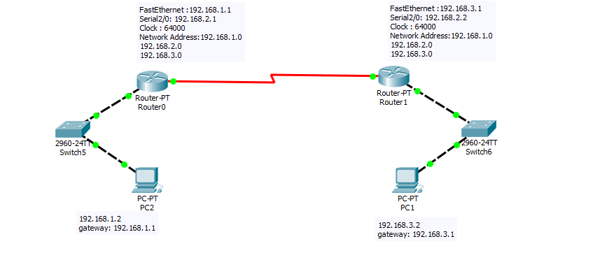
Command line Configuration :
Router(Config)# router rip
Router(Config-router)# network 192.168.1.0
Router(Config-router)# network 192.168.2.0
Router(config-router)# version 2
Router(Config-router)#exit
Output:
Last Status | Source | Destination
Successful | PC! | PC2
Successful | PC2 | PC1

Conclusion:
This lab is not different from previous one here we have also learn how to rip two router with little bit of upgrade version.

Experiment-10
Aim:- Design & implement a network setup for our University

Theory:-
Switch: A network switch or switching hub is a computer networking device that connects network segments. The term commonly refers to a network bridge that processes and routes data at the layer (layer 2) of the OSI model. Switches that additionally process data at the network layer (layer 3 and above) are often referred to as Layer 3 switches or multilayer switches.
Router: A router is an electronic device that interconnects two or more computer networks, and selectively interchanges packets of data between them. Each data packet contains address information that a router can use to determine if the source and destination are on the same network, or if the data packet must be transferred from one network to another. Where multiple routers are used in a large collection of interconnected networks, the routers exchange information
Topology:-
Smartphone
Access point-PT
2960-24TT IT-Switch
PC-PT1
PC-PT2
2911-Router
PC-PT3
PC-PT4
Server-PT1
HTTPServer
Server-PT2
DNS server
Server-PT3
DHCP Server
2960-24TT
Server Farm

2960-24TT
HR Switch

Addressing table:-
Device | Interface | IPv6 address/prefix |  | Default gateway | comments
 |  | IP address | Subnet mask
R1 | G0/0 | 2001:DB8:ACAD:1::1/64 |  | Not applicable | Connected to IT-Switch G0/1
 |  | 192.168.1.1 | 255.255.255.128 | Not applicable
 | G0/1 | 2001:DB8:ACAD:128::1/64 |  | Not applicable | Connected to HR-Switch G0/1
 |  | 192.168.1.129 | 255.255.255.192 | Not applicable
 | G0/2 | 2001:DB8:ACAD:1::1/64 |  | Not applicable | Connected to SERVER-FARM G0/1
 |  | 192.168.1.193 | 255.255.255.224 | Not applicable
IT-Switch | VLAN1 | 192.168.1.2 | 255.255.255.128 | 192.168.1.1 | SVI for IT-Switch management
HR-Switch | VLAN 1 | 192.168.1.130 | 255.255.255.192 | 192.168.1.129 | SVI for HR-Switch management
SERVER-FARM | VLAN 1 | 192.168.1.194 | 255.255.255.224 | 192.168.1.193 | SVI for SERVER-FARM management
HTTP SERVER | NIC | 2001:DB8:ACAD:1::1/64 |  | FE80::1 | Connected to SERVER-FARM Fa0/1
 |  | 192.168.1.221 | 255.255.255.224 | 192.168.1.193
DNS SERVER | NIC | 2001:DB8:ACAD:1::1/64 |  | FE80::1 | Connected to SERVER-FARM Fa0/2
 |  | 192.168.1.222 | 255.255.255.224 | 192.168.1.193
DHCP SERVER | NIC | 2001:DB8:ACAD:1::1/64 |  | FE80::1 | Connected to SERVER-FARM Fa0/3
 |  | 192.168.1.220 | 255.255.255.224 | 192.168.1.193
IT-PC1 | NIC | 2001:DB8:ACAD:1::1/64 |  | FE80::1 | Connected to IT-Switch Fa0/1
 |  | 192.168.1.3 | 255.255.255.128 | 192.168.1.1
IT-PC2 | NIC | 2001:DB8:ACAD:1::1/64 |  | FE80::1 | Connected to IT-Switch Fa0/2
 |  | 192.168.1.4 | 255.255.255.128 | 192.168.1.1
HR-PC1 | NIC | 2001:DB8:ACAD:1::1/64 |  | FE80::1 | Connected to HR-Switch Fa0/1
 |  | 192.168.1.131 | 255.255.255.192 | 192.168.1.1
HR-PC2 | NIC | 2001:DB8:ACAD:1::1/64 |  | FE80::1 | Connected to HR-Switch Fa0/2
 |  | 192.168.1.132 | 255.255.255.192 | 192.168.1.129
Guest_phone | Wireless  NIC | SLAAC |  |  | Wirelessly connected to AP_Guest
 |  | DHCP

Set the topology as shown in above figure.
Step 1: Configure the router host name.
Set the host name on the router to R1 by using these commands.
- Router>enable
- Router#configure terminal
- Router(config)#hostname R1
Step 2: Configure the privileged mode and secret passwords.
a. In global configuration mode, set the password to cisco.
- R1(config)#enable password cisco
- Set an encrypted privileged password to cisco123 using the secret command.
- R1(config)#enable secret cisco123
Step 3: Configure the console password.
a. In global configuration mode, switch to line configuration mode to specify the console line.
- R1(config)#line console 0
- Set the password to cisco123, require that the password be entered at login, and then exit line configuration mode.
- R1(config-line)#password cisco123
- R1(config-line)#login
- R1(config-line)#exit
- R1(config)#
Step 4: Configure the vty password to allow Telnet access to the router.
a. In global configuration mode, switch to line configuration mode to specify the vty lines.
- R1(config)#line vty 0 15
- Set the password to cisco123, require that the password be entered at login, exit line configuration mode, and then exit the configuration session.
- R1(config-line)#password cisco123
- R1(config-line)#login
- R1(config-line)#exit
- R1(config)#
Step 5: Configure password encryption, a MOTD banner, and turn off domain server lookup.
a. Currently, the line passwords and the enable password are shown in clear text when you show the running configuration. Verify this now by entering the show running-config command.
To avoid the security risk of someone looking over your shoulder and reading the passwords, encrypt all clear text passwords.
- R1(config)#service password-encryption
- R1(config)#banner motd Authorized Access Only
- R1>emable
Translating "emable"...domain server (255.255.255.255)
To prevent this from happening, use the following command to stop all DNS lookups from the router CLI.
Save the running configuration to the startup configuration.
- R1(config)#end
- R1# copy run start
FOR A IT-SWITCH:
Step 1: Establish a console connection to a switch.
For this activity, direct access to the IT-Switch Config and CLI tabs is disabled. You must establish a console session through IT-PC1.
Step 2: Configure the host name and VLAN 1.
a. Configure the switch host name as IT-Switch.
b. Configure port Fa0/1. Set the mode on Fast Ethernet 0/1 to access mode.
- IT-Switch (config)#interface fastethernet 0/1
- IT-Switch (config-if)#switchport mode access
c. Configure IP connectivity on S1 using VLAN 1.
- IT-Switch (config)#interface vlan 1
- IT-Switch (config-if)#ip address 172.17.99.11 255.255.255.0
- IT-Switch (config-if)#no shutdown
FOR SERVER-FARM:
Step 1: Establish a console connection to a switch.
For this activity, direct access to the SERVER-FARM Config and CLI tabs is disabled. You must establish a console session through IT-PC1.
Step 2: Configure the host name and VLAN 1.
a. Configure the switch host name as IT-Switch.
b. Configure port Fa0/1. Set the mode on Fast Ethernet 0/1 to access mode.
- SERVER-FARM (config)#interface fastethernet 0/1
- SERVER-FARM (config-if)#switchport mode access
c. Configure IP connectivity on S1 using VLAN 1.
- SERVER-FARM (config)#interface vlan 1
- SERVER-FARM (config-if)#ip address 172.17.99.11 255.255.255.0
- SERVER-FARM (config-if)#no shutdown
Output:-
Last Status | Source | Destination
Successful | Smartphone | PC1
Successful | PC2 | PC1
Successful | Smartphone | PC4
Successful | PC | Smartphone

Conclusion:-
We have designed & simulated a network setup for our University

